Test Station Development Using the UCF Framework v030123
Richard Todd
Test Engineering Services
Requires libTeSequencer.(so | dll) v012623 or later.
Requires UniConsole(.exe) v012623 or later.
Requires StdIOChannelSystem(.so | dll) v012623 or later.

Purpose
This document defines the process to develop, verify and deploy an automated test station using the UniConsole Framework (UCF).
The focus of this document is primarily on using the UCF to integrate and automate the test station.
The intended audience for this document are test engineering developers using the UCF to build, automate and verify an electronic functional test station.

Terminology
Term | Definition
UCF | The UniConsole Framework
Test Spec (ification) | A document that defines each parameter to be tested, and the generic methodology used to create the measurement value.
Management Console | The tab/text based console that is used to monitor and control all application functionality
Test Executive | The user interface used to automatically sequence all tests and save measurement data to a local database
Go-nogo | A test sequence initiated by the test executive will stop on the first measurement failure
Host Computer | The computer that will control the test station’s instrumentation
Test Profile Group | The ‘./ucfroot/opt/MyTestGroup/’ directorycontains the ‘Test Profile’ subdirectory as well as a common IO configuration database.
Test Profile | The ‘./ucfroot/opt/MyTestGroup/INSTANCE’ directory that contains 1 or more shared libraries that will be automatically loaded in order to create the test application.
Test Project Directory | The directory used to create a new test automation application. The initial contents are copied from ./ucfroot/usr/src/_TplModule/*
Takt Time | Takt time is the average time interval between the start of production of one unit and the start of production of the next unit when items are produced sequentially.

Related Documents
Document | Description
UCF Introduction Notes.pdf | This document provides an introduction to the UCF user interfaces and deployment structure
UCF Test Executive Configuration Notes.pdf’ | This document defines the UCF test executive configuration process
UCF Installation Guid.pdf | This document defines the UCF installation process
UCF Module Development Guide.pdf | This document details the UCF module development process

Pre-Conditions
The UCF must be installed and verified on the host computer before proceeding with this document.
See ‘UCF Installation Guid.pdf’ for installation details.

The Development Process Overview
This section provides an overall outline of the test station development process.

Test Specification Creation
A test spec for the target UUT type is created that defines test content and initial test limits. A UCF database is configured contain the test spec name and test limits as defined in the test specification.

Test Station Hardware Design
The test system is designed using instrumentation and fixtures required by test specification.

Test System Integration
The test system instrumentation is assembled and a force and measurement module is developed using the UCF.

Test Application Development
UCF test applications are shared libraries that implement the measurements define in the test specification.

The UCF Profile Group Creation
A profile group is created that will contain 1 or more related test profiles.

Test Project Directory Creation
A template is used to create a new QT or Visual Studio C++ project.

Test Project Configuration
The test project’s directory paths and file content are configured.

Instrument Communication Settings Configuration
IO databases are configured to enable is communication with all system instrumentation and UUT’s.

Instrument Initialization and Shutdown
Code is developed to initialize and shutdown system instrumentation.

Instrument Control
Code is developed to provide an abstracted interface to system instrumentation.

Test Group Development
Code is developed to test a specific and closely related group of parameters.

Test Sequence Development
Code is developed to test specific UUT parameters using the abstracted system interface.

UUT Test Sequence Verification
Code is developed to initialize and provide an abstracted interface to system instrumentation.

Test Specification Creation
A test specification is a version controlled document that specifies what parameters will be tested, the methodology used for each measurement and the pass/fail limits. A test specification is a ‘root’ requirement for test station development.
- The name of each parameter to be tested
- For each parameter, the instrumentation independent test methodology that will be used.
- The initial pass / fail limits for each parameter.

UCF Test Specification Database Configuration
Using the document created in section 5.1, the UCF test specification database(s) are configured.
See the ‘UCF Test Executive Configuration Notes.pdf’ document for detailed information.

Test Hardware Design
The test station hardware is designed based on the tests required by the test specification, the required manufacturing through-put, and budgetary requirements.

Instrumentation Selection
Instrumentation is selected based on the requirements defined in the test spec, and the target manufacturing Takt times.

The instrumentation should contain ethernet, serial or USB automation interfaces.

The interfaces should be configured in the UCF system initialization database(s)
See the ‘xx.pdf’ document for detailed information.

Test Fixture Design
Test fixturing for both the DUT and instrumentation is designed using Takt time and manufacturing floor requirements as major considerations.

Using an ‘instrumentation rack with wheels’ or ‘everything on a bench’ approach may be very dependant on the selected contract manufacturer.

Test System Documentation
Documentation is created that will allow the following operations.

Assembly and repair of a complete system by technician level personnel.
  - Schematic
  - BOM

Assembly of a complete system by technicians or operators at remote locations.
  - Assembly process (may be used extensively when deploying to remote locations)
  - Verification procedure

Test System Integration
The test system ins assembled and integrated with the UCF prior to verification and development of specific functional tests. At the end of the integration, the system will be ready for test development.

Prereqisites

The test station has been assembled using the documentation created in section 7.3

The UCF is has been installed on the develolpment computer.

The Qt or Visual Studio IDE has been installed on the development computer.

A template project has been created for either Qt or visual studio.
See the ‘UCF Installation Guide.pdf’ for details.

System Abstraction Layer Development
A ‘system abstraction layer’ is an object that interfaces generic force and measurement commands to specific instrument control code.

The abstraction layer code is implemented in a C++ object.

The system abstraction layer is used by registered commands within an application module (TplModule.h/cpp) to innteractively control instrumentation
See ‘UCF Module Development Guide.pdf’ for details.
Example Code
int TplModule::MeasureControlVoltage(CmdParam msg) {
/* Create a measurement function to directly measure a test instrumentation input */

double measurement_value {1.234};
iUcfTestExec exec(msg,ModuleId);

measurement_value = TheAbstractionLayer.MeasureControlVoltage();

StdOutConsole.Write(
IOString("Control voltage = %2.4f",measurement_value),
iStdOut::Text1
);

return(1);
}

int TplModule::Start() {
/* Register a force/measure function to be called from the command line */
Cmds=TheAppEngine->iGet<CmdRepository::iMethodServer>(ModuleId);

if (Cmds) {
Cmds→RegisterApplicationCmd(
"MeasureRefVoltage",
new Ucfx(&TplModule::MeasureControlVoltage,this),
"()\tMeasure the UUT reference voltage"
);
}

return(1);
}

Force & Measurement Command Development
Each registered command can be debugged and verified using the Management Interface Console.
  - Type ‘help <cr>’ to see a list of available commands
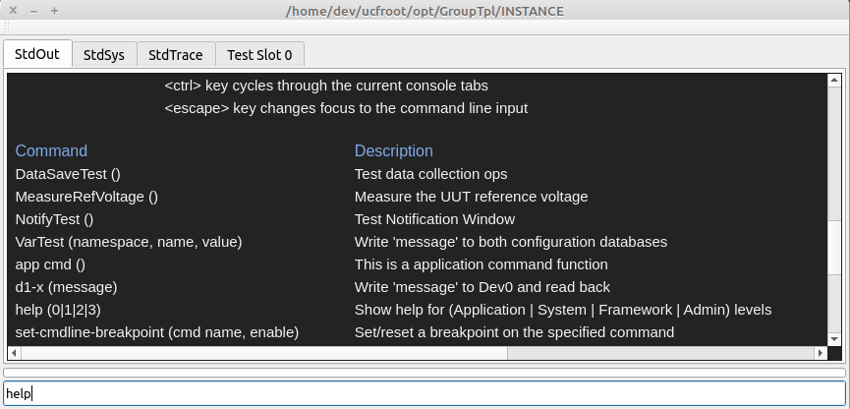
  - Type ‘MeasureRefVoltage <cr>’ to execute the selected command.
Note: The console has ‘tab command completion. Typing ‘Me <tab>’ will select ‘MeasureRefVoltage’

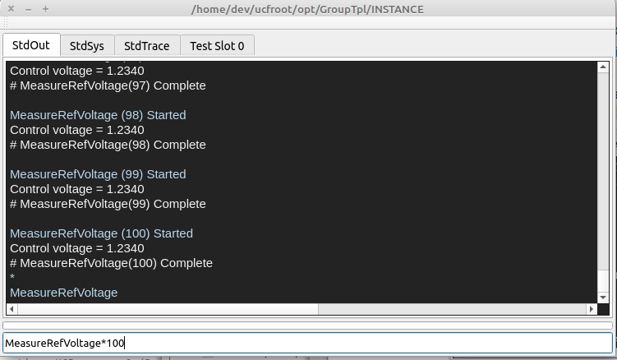

Test System Verification
The test system is verified by using the UCF console to exercise all force and measurement calls provided by the ‘abstraction layer’. Each force and measurement call is a ‘Registered’ function within the application module.

Each force or measurement call is made 100 consecutive times.

The accuracy and repeatability of each call is documented and determined to be acceptable for the test measurements to be made.
  - Type ‘help <cr>’ to see a list of available commands
  - Type ‘MeasureRefVoltage*100 <cr>’ to sequentially execute the command 100 times.
Note: The console has ‘tab command completion. Typing ‘Me <tab>’ will select ‘MeasureRefVoltage’

  - Review the output and document the measurement accuracy and repeatability.

Test Sequence Development
This section outlines developing test sequences in a shared library that implement the measurements defined in the test specification.
Individual tests are functions that measures a parameter using calls to the system abstraction layer.
Test functions are then registered in the UCF test executive to create a test sequence.

Prerequisites
The following steps are required before implementing this section

Test specification development

Test station design & integration

Sequence Development Process

Test sequences are built using individual test functions for each parameter, or group of related parameters.

Test functions use generic force and measurement calls to create individual test cases that save data to the embedded database.

Test functions are ‘registered’ with the UCF test executive in order create a test sequence.

Example TplModule.cpp Code
int TplModule::TestControlVoltage(CmdParam msg) {
/* Create a measurement function to directly measure a test instrumentation input */

double measurement_value {1.234};
iUcfTestExec exec(msg,ModuleId);
measurement_value = TheAbstractionLayer.MeasureControlVoltage();
if (exec.IsValid()) {
/* If the function was called by the test executive */
exec.SaveMeasurement("Ref_Output","Voltage",measurement_value,1.2 ,1.8);
}
else {
StdOutConsole.Write(
IOString("Control voltage = %2.4f",measurement_value),
iStdOut::Text1
);
}

return(1);
}

int TplModule::Start() {
/* Create a test sequence using test functions*/
if (TheTestExec) {
TheTestExec→RegisterTestFunction(
"GetSn", "()\tGet the UUT serial number", new Ucfx(&TplModule::Test1, this));
TheTestExec→RegisterTestFunction(
"Control Voltage","()\tTest the control voltage", new Ucfx(&TplModule::TestControlVoltage, this));

…
}

Executing Test Sequences
Test sequences can be executed using the graphical user interface, or from the management console.

Execution using the GUI Test Executive
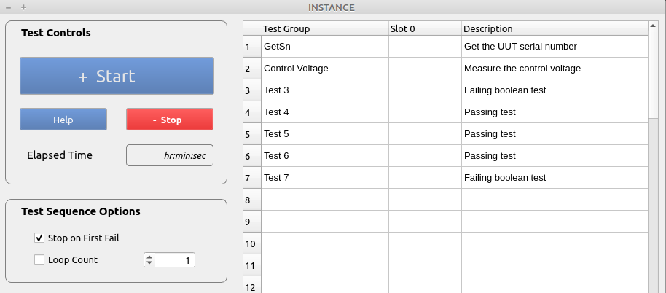
  - The test sequence is executed by selecting the ‘Start’ button.
  - The stop button will synchronously terminate a test sequence at the end of the current test function.

Execution using the Management Console
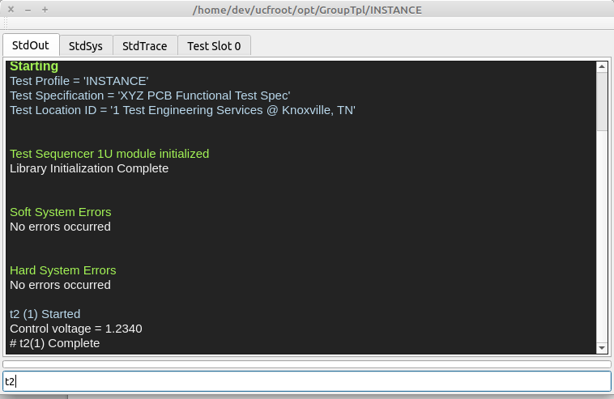
  - An individual test (T2) from the test executive, can be executed using the ‘t2 <cr>’ command.
  - A complete test sequence can be executed using the ‘start-test’ command.
  - A complete test sequence can be executed multiple times using the ‘start-test*n’ command where ‘n’ is the number of times to repeat.
  - A test sequence can be stopped asynchronously using the ‘abort-session’ commands
  - A test session can be stopped synchronously (after the sequence completes) using the ‘stop-session’ command.

Validating a Test Sequences

Debug When Errors are Suspected

  - A BOM is created from the schematic.

The UCF Profile Group Creation
A profile group is a collection of 1 or more related test profiles that share common instrumentation configuration information.

The ‘ucfroot’ distribution package installation.
The ‘ucfroot’ directory from the installation package is copied to either ~/ for linux, or c:\ for windows.

Profile Group Creation
./ucfroot/opt/GroupTpl/* is copied into ./ucfroot/opt/MyTestGroup to create the target test group.

Test Project Directory Creation
A test project directory is created using the CmakeLists.txt and source files located in ./ucfroot/usr/src/_TplModule/*

./ucfroot/usr/src/_TplModule/* is copied to a user defined project location.

Test Project Configuration

The CmakeLists.txt is modified to reflect new template source code locations.

The CmakeLists.txt is modified to include any required files from ./ucfroot/usr/src/<Release Name>/Api.

The CmakeLists.txt is modified to build the shared library into Test Profile directory.

The CmakeLists.txt is used to create a new QT or Visual Studio project.
After the project is created, it can be maintained and updated without using cmake and the CmakeLists.txt file, if desired.

Instrument Communication and Initialization
****

UCF Overview
The UCF framework uses components that are deployed in a standardized directory structure.
- A GUI based management interface (console) that is used to interactively control the test station
- A GUI based test executive and sequencer that executes test sequences and saves data
- The UniConsole application and support shared libraries
- User defined shared library(s) that implement product specific test sequences
- Embedded configuration databases
- An embedded measurement data data-base

A standardized deployment structure simplifies current and future software maintenance and upgrades.

All stations developed by multiple test engineers will be configured identically.

All stations will retain the same deployment configuration over extended periods of time.

Multiple deployment schemes from multiple developers are avoided to reduce support requirements.
See ‘UCF Introduction Notes.pdf’ for detailed information

The Management Interface
The use of the management interface is the single most powerful development and maintenance feature of the UniConsole Framework.
The Management interface is a UCF specific console that allows a user to interactively control a test station and monitor real-time configuration and status information.

User defined test or utility functions can be interactively executed.

System instrumentation can be interactively controlled.

Complete test sequences can be executed 1-n times without requiring the GUI test executive.
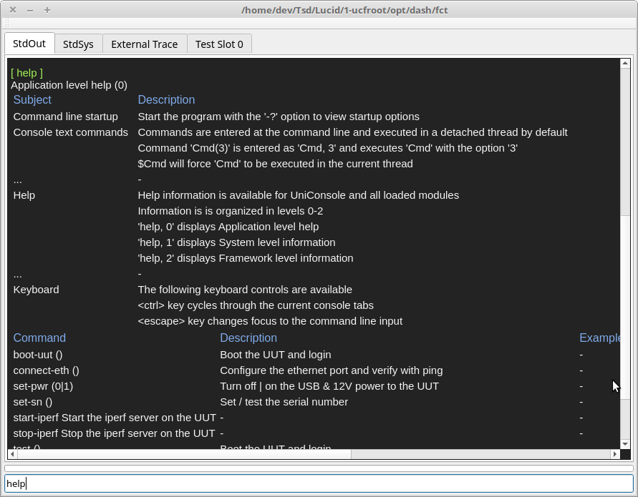
All interactive commands can be listed using the ‘help’ command.
Examples:

‘5*start-test’ will execute the registered test sequence 5 times

‘10*start-test, 1’ will execute the registered test sequence 10 times where each sequence will stop on first fail.

‘abort-session’ will asynchronously abort a test session at the end of the current test step.

‘stop-session’ will synchronously abort a test session at the end of the current test sequence.

‘tn <cr>’ will execute test #’n’ from the GUI test executive.

‘5*tn <cr>’ will execute test #’n’ 5 times consecutively.

‘5*tn,1 <cr>’ will execute test #’n’ 5 times consecutively with ‘gonogo’ mode enabled.

‘power, 0|1 <cr>’ will disable | enable system power where ‘power’ is a user defined & registered function.

See ‘UCF Introduction Notes.pdf’ for detailed information.

Configuration Settings
The following test executive startup settings can be configured using system variables. These settings are optional.

Management Console GUI interface size and location

Test Executive GUI interface size and location

The initial test mode (Go-nogo)

The manufacturer's name and location of the test station

Test specifications, parameters and limits for each test profile

The number of units to be tested concurrently

Manual UUT serial number verification

System variables
System variables are stored in local or global sqlite databases and are configured using the ‘DB Browser for Sqlite’ application.

Locations
Database Type | Database Location | Platform
Local | ~/ucfroot/opt/<Profile Family Name>/ExtSystemIO.sdb | Linux
 | C:\ucfroot\opt\<Profile Family Name>\ExtSystemIO.sdb | Windows
Global | ~/ucfroot/bin/<Release Name>/IOConfig/BaseSystemIO.sdb | Linux
 | C:\ucfroot\bin\<Release Name>\IOConfig\BaseSystemIO.sdb | Windows

Local database values are unique to a specific profile family and will override values in global databases.

Global database values will be used for all profiles that do not have overriding values in a local database.

User Interface Configuration
The Management Console and Test Executive user interface can be optionally configured using system variables.
- Management Console window size & location
- Test Executive window size & location
- Initial test mode (Go-nogo enable)

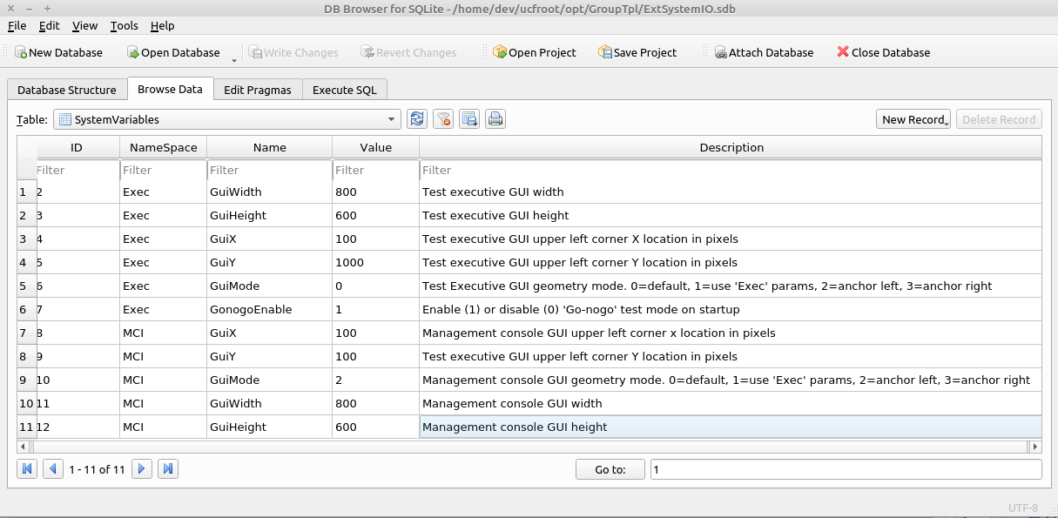

Where
‘Exec::GuiMode’ specifies the display mode of the test executive user interface.
0=default
1=use ‘Exec’ system variables to set geometry
2=anchor left
3=anchor right
‘MCI::GuiMode’ specifies the display mode of the management console user interface.
0=default
1=use ‘Exec’ system variables to set geometry
2=anchor left
3=anchor right
‘Exec::GuiMode’ specifies the execution mode of the test executive on startup.
0=Do not stop on first test failure
1=Stop on first test failure

Test Specification Configuration Process
The test executive is designed to use test limits from a version controlled test specification. Each parameter saved in the database is traceable to
- The test specification used to determine pass/fail status
- The manufacturers name and physical location
- The test station used to save the parameters
Test specification information is stored in local sqlite database and is configured using the ‘DB Browser for Sqlite’ application.

Database Type | Database Location | Platform
Manufacturing ID | /var/lib/ucf/Static.sdb | Linux
 | C:\ucfroot\var\lib\Static.sdb | Windows
Test Specifications | /var/lib/ucf/TestLimits.sdb | Linux
 | C:\ucfroot\var\lib\TestLimits.sdb | Windows

Manufacturing ID
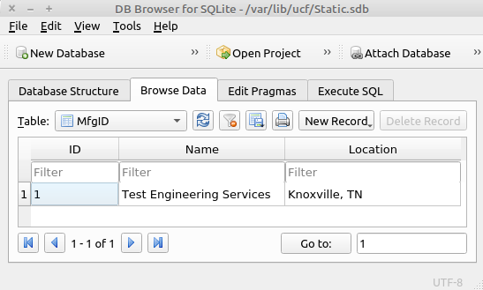

‘Name’ is the name of the manufacturing company.

‘Location’ is the location of the manufacturing company.

Only the first record is used. All additional entries will be ignored.

Test Specification(s)
Any number of test specifications can be set in the TestLimits::TestSpecIndex table.

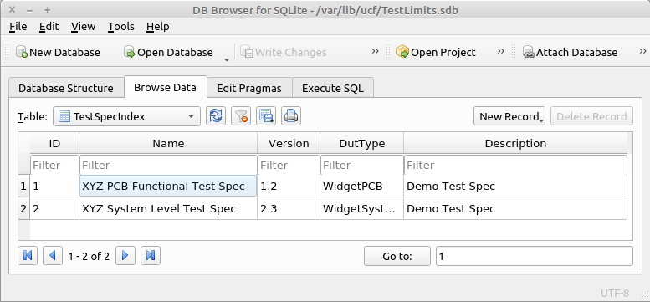

‘ID’ is the numeric identifier used to reference each test specification

‘Name’ is the name of the test specification

‘Version’ is the version of the test specification. Multiple versions can be specified

‘DutType’ is the name/type of UUT to be tested

‘Description’ is a brief description of the test specification

Test Profile Maps(s)
The test profile map table specifies which test specification will be used for each UCF profile.

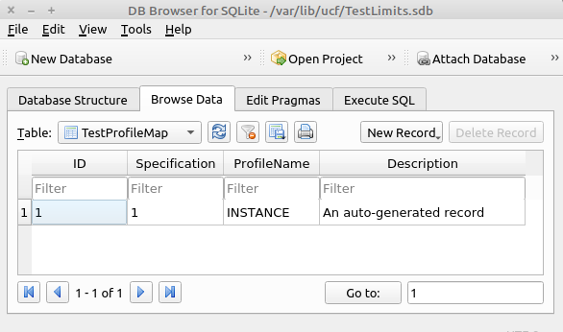

Specification’ corresponds to a test specification ID defined in TestLimits::TestSpecIndex

‘ProfileName’ is the last element in the file path specified when starting the UniConsole framework.

Example UCF startup command:
‘./UniConsole(.exe) -p /home/dev/ucfroot/opt/GroupTpl/INSTANCE‘
Where INSTANCE is the profile name

Test Limits
The test profile map table specifies which test specification will be used for each framework profile.

This table will be automatically populated the first time the test sequence is executed and will use the the
default values specified in the test program. Subsequent test sequence executions will not modify the test limits.

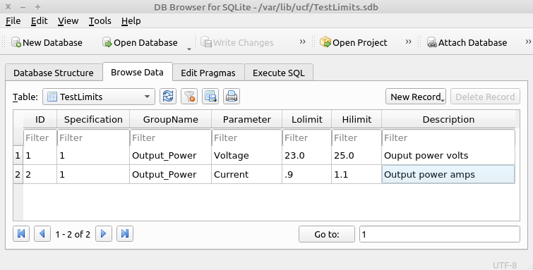

Specification’ corresponds to a test specification ID defined in TestLimits::TestSpecIndex.

‘GroupName' is a category or namespace.

‘Parameter’ is the name of a specific measurement.

‘Lolimit’ is the lower pass/fail threshold. Passing values are >= ‘Lolimit’.

‘Hilimit’ is the upper pass/fail threshold. Passing values are <= 'Hilimit.

Slot Count & Verify Serial Number
The framework is capable of testing 1-16 UUT's concurrently and can require that a serial number be manually entered at the start of a test sequence. These values are optional and will default to ‘1’.

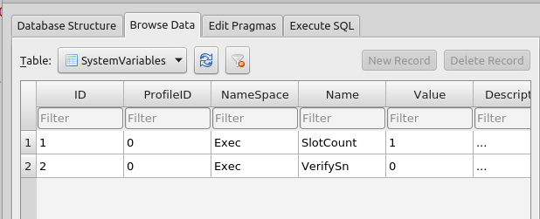

‘ProfileID’ is not used.

‘NameSpace’ = ‘Exec’

‘Name’ = ‘SlotCount’ | ‘VerifySn’

‘SlotCount’ is the number of units to be tested concurrently (1-16).

‘VerifySn’ enable/disables manual input of a serial number at the start of a test sequence.

See section 3.2 for additional system variable information

****

Prereqisites

The test station has been assembled using the documentation created in section 7.3

The UCF is has been installed on the develolpment computer.

The Qt or Visual Studio IDE has been installed on the development computer.
See the ‘UCF Installation Guide.pdf’ for details.

